Assignment for CLVD PART 1

Student number: Mpumelelo Chonco
Student number: st10449316
Date due: 15 April 2026

- Design the EventEase Database
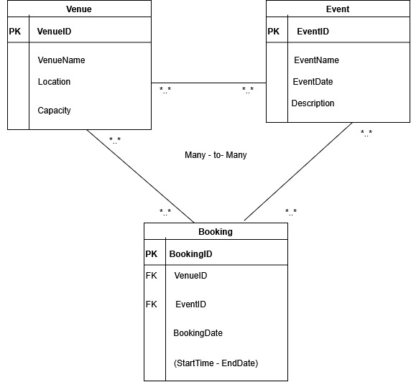

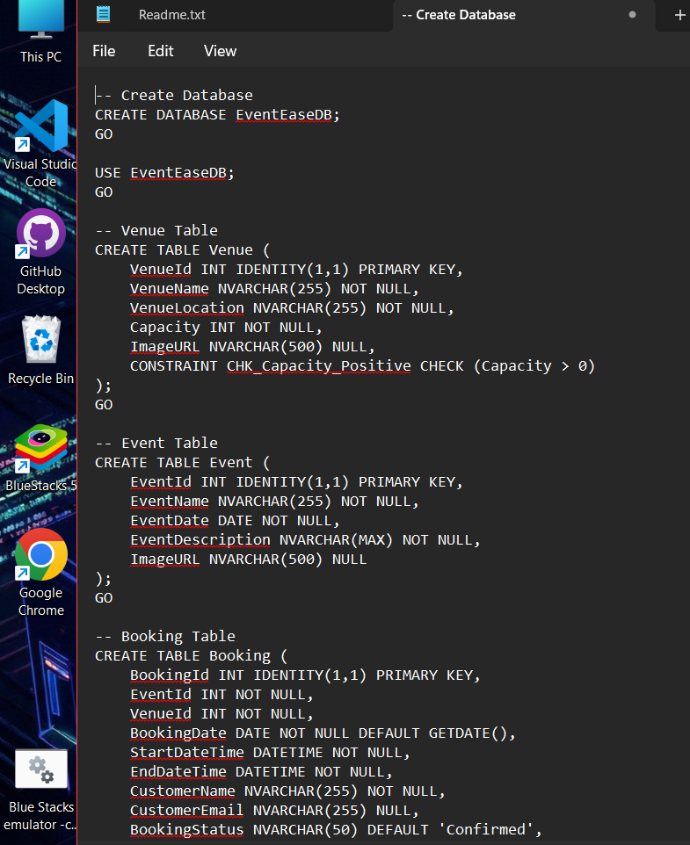
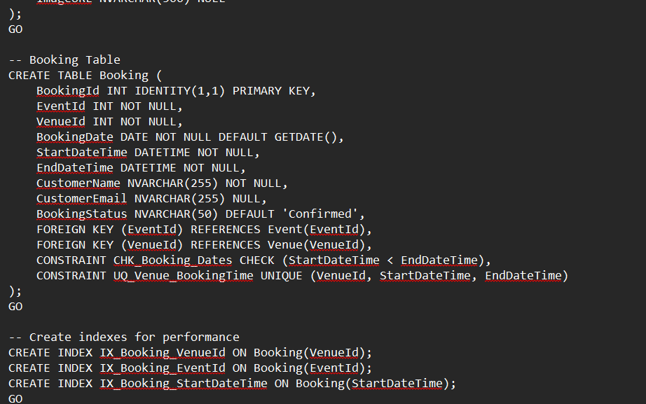

- Developing the Web Application

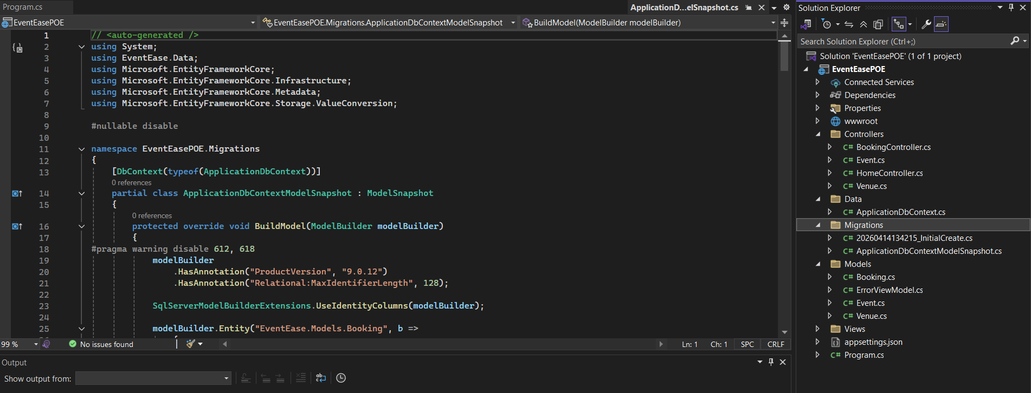
This screenshot shows the controllers, models for Event, Venue, and bookings created as well as the migration.
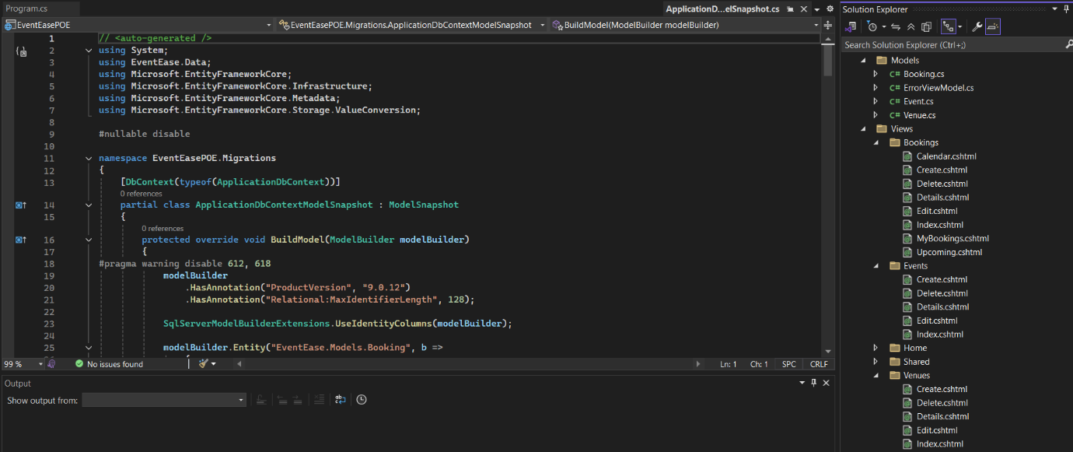
This screenshot shows the views of the Venue, Event, and Bookings created.
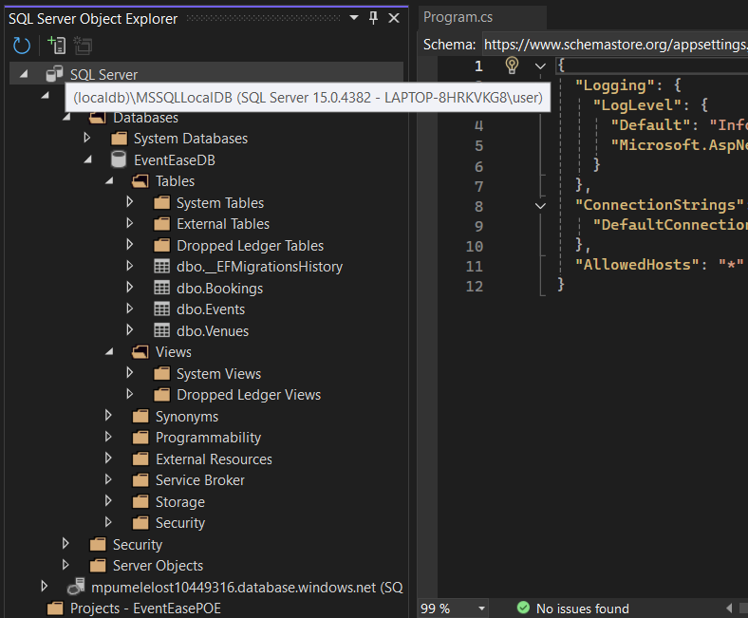
Proof it communicates with the SQL LocalDB
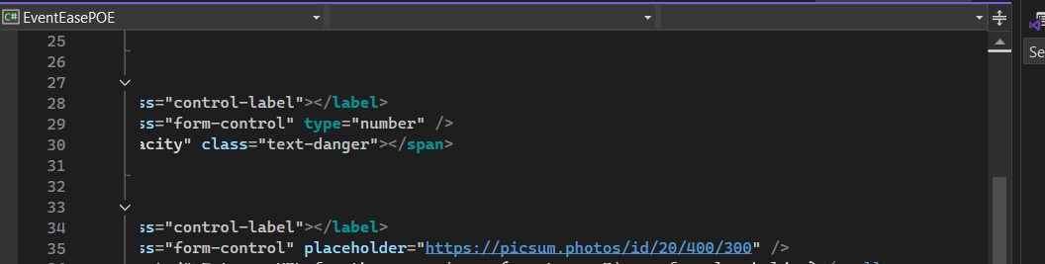
Example of placeholder URLs for the images used in my EventEasePOE
C. Local Persistence Setup
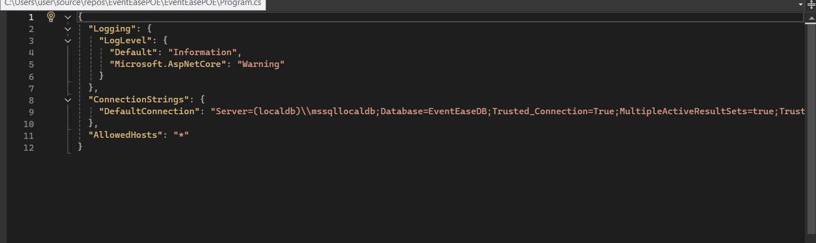
This is the appsettings.json configured to the local database
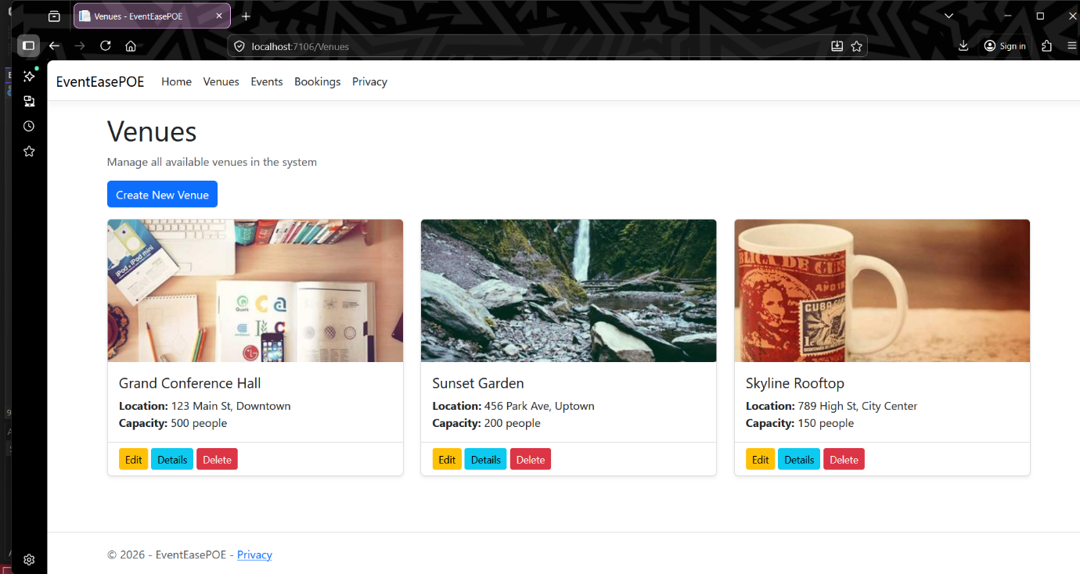

GitHub Link: https://github.com/Modies20/CLDV6211-PART-1.git

D. Computing Cloud Basics
1. Differences Between Cloud and On Premises Deployment

Instead of buying hardware, you get access to computing resources through providers like AWS, Azure, or GCP. These services supply what you need without requiring physical setup on your part. Using remote systems means less hands-on maintenance. The infrastructure runs offsite, managed by the vendor. What you use is delivered over the internet, ready when needed. Once the switch happens, things shift - how teams handle infrastructure, how fast they build, how protection is managed - all start looking different. Because control moves outside internal IT, decisions unfold in new ways. Tools adapt around access rather than ownership. Speed picks up, yet oversight demands fresh thinking.

A) Security
Most times, cloud companies split safety tasks with users. When it comes to apps, settings, and information stored online, you handle protection. The platform running beneath those pieces - like servers and networking gear - gets guarded by the service behind the tech. With systems set up locally, though, every part of defense lands on your team. That includes physical access, traffic controls, plus software safeguards, all managed internally.

Out in the world, cloud providers run many data centers far apart from one another. These spots come ready with backup strategies if something goes wrong. Access is tightly managed - only certain people can get close. Fire protection systems stand guard just in case. When businesses keep tech onsite instead, how safe it ends up being depends a lot on what they’ve got and who’s handling it. Some do well; others less so. Guidance like NIST’s from 2011 shows these differences clearly.

Security that grows with you shows up built into many cloud systems. Think spotting threats, handling encryption keys, managing who gets in - all part of the package. On-site setups might do the same job, yet often demand extra spending before launch. Expert teams tend to be required. Setup takes hands-on work, step by step. Each choice shapes how tight the controls become.

B) Development speed
Minutes replace months when setting up systems, thanks to cloud tools. Instant access arrives through virtual spaces online instead of waiting on physical gear delivery. Setup delays shrink dramatically once teams start building in environments like Microsoft Azure. Speed multiplies because installation loops get skipped entirely.

Cloud systems often include built-in tools for smooth code updates and frequent releases. Instead of handling everything manually, teams get automated workflows that speed things up. Running the same processes locally tends to take more effort and planning. Setup challenges pop up when infrastructure isn’t hosted online.

Startups often move faster because someone else handles the hard parts behind the scenes. Code gets written quicker when engineers skip setting up servers by hand. New tools appear more often once routine chores vanish into the background. Someone’s always patching systems so developers can focus elsewhere. Features come alive while others manage network knots far away.
C) Resource Management
- Scaling up or down happens smoothly with cloud setups - need more power today? Just grab it. Paying only for actual usage makes this flexible approach cost effective over time. Physical servers bought upfront demand big spending early, even if they sit idle later. That kind of expense ties money up without guaranteeing returns.

- Most cloud services work like a utility bill - you pay only for what you use. That kind of spending fits well when trying new ideas or growing fast. Instead of big purchases up front, teams adjust usage as needed. Running your own servers means buying hardware first, then fixing it later. Those setup fees add up quickly. Ongoing repairs and updates take time plus money too. Cloud pricing skips much of that burden.

- Most cloud setups use code-based systems such as AWS CloudFormation or Azure Resource Manager, along with coordination platforms like Kubernetes for container workloads. These tools aren’t exclusive to the cloud - yet applying them locally often demands extra effort. Working with on-site infrastructure typically requires deeper expertise, making deployment slower compared to cloud options. Complexity rises when managing physical hardware without built-in automation features found in cloud providers

A small company building a web app might spin up a cloud function through AWS, push its code live, then check how it runs - all within just one morning. In contrast, if that team tried doing the same thing using office-based hardware, they could spend entire weeks waiting for actual machines to arrive, installing software by hand, adjusting firewalls, tuning connections.

2. Differences Between IaaS, PaaS, and SaaS and Why EventEase Might Benefit from PaaS
A) IaaS, or infrastructure as a service
Out in the digital world, IaaS hands you access to networks, storage, and virtual computers via the web. Running on that setup means you handle installing each system yourself. What sits above it - the OS, programs, tools - all lands in your court to manage. Responsibility trails every app you set up there. IBM Cloud notes this model leaves control mostly with the user. That foundation rests online, ready when needed.

Take Google Compute Engine on Google Cloud. Then there is Microsoft Azure Virtual Machines too. Amazon EC2 runs under AWS, another option altogether.
Perfect when teams face tricky setups needing careful handling. Works well where precise adjustments matter most. Great for crews managing complex systems without hiccups. Fits situations demanding steady oversight across unique configurations.

B) PaaS, or platform as a service
PaaS gives a space where building, running, plus managing apps happens smoothly - minus the need to handle servers or hardware. Inside this setup lives an OS, tools for live updates, coding structures, among others (Red Hat, n.d.).

Take Microsoft Azure App Service, for instance. Then there's Google App Engine - another option worth noting. AWS Elastic Beanstalk fits here too, working much the same way.
Most times, folks skip server setup when using this tool. Rather than deal with infrastructure, they write code right away. Since it links into automated workflows, speed comes naturally. Without handling hardware details, building apps gets easier. The whole process moves faster because teams focus only on what matters. Rarely do people worry about maintenance here.
Software you rent instead of buy. It runs online through your browser. Updates happen automatically behind the scenes. You pay a fee to keep using it over time. Access works from any device with internet
What happens is this. Firms use tools such as Salesforce or Microsoft 365 through ongoing subscriptions. Instead of buying once, they pay regularly to keep using them. Users avoid hardware setups and open specific digital resources directly within web browsers for simplified project management across separate devices. Control stays with the provider - users cannot change the underlying system or code. What they can do, though, is adjust settings to fit their needs.

When managing customer data or handling daily tasks, some tools work without needing constant updates. These fit well where full features matter more than control.

The Potential Benefits of PaaS for EventEase

- PaaS lets EventEase skip setting up servers, so it can spend time building event tools instead. That means updates come out faster. Getting things done without waiting around helps speed everything up. Releasing new bits of software becomes simpler when there is less setup work first.

- When traffic jumps during big moments, the system grows right along with it - no extra steps needed. Scaling happens quietly behind the scenes, driven by real-time needs rather than preset limits. This kind of flexibility matters most when crowds surge unexpectedly at key times. Instead of preparing for every peak, resources adjust on their own. What you get is a steady flow even when demand shoots up without warning.

- PaaS takes care of server management so operations teams can shift focus. Instead of handling routine upkeep, they spend time improving how users interact with systems. Tasks like securing data and meeting compliance needs gain more attention. The burden of maintaining hardware fades into the background. Attention moves toward what matters inside the application. Routine chores lose priority without disappearing completely.

- Some PaaS platforms include tools like message queues, storage systems, data analysis, and connection points - these help EventEase build functions more quickly (AWS, n.d.-c; Microsoft Azure, n.d.).

Even so, using SaaS might not hit the mark for a custom event app, particularly when off-the-shelf features skip key needs of EventEase. On the flip side, going with IaaS pulls you into managing operating system patches and environment configs yourself, racking up extra work. Not a setup you just run. Needs careful checking of server settings before anything works right.

REFERENCING
Singh, U.K. and Sharma, A., 2021. Cloud computing security framework based on shared responsibility models: Cloud computing. In Cyber-Physical, IoT, and Autonomous Systems in Industry 4.0 (pp. 39-55). CRC Press.
(Accessed: 4 April 2025).

Kulkarni, G., Sutar, R. and Gambhir, J., 2012. Cloud computing-Infrastructure as service-Amazon EC2. International journal of Engineering research and applications, 2(1), pp.117-125
(Accessed: 5 April 2025).

Mishra, P., 2023. Advanced aws services. In Cloud Computing with AWS: Everything You Need to Know to be an AWS Cloud Practitioner (pp. 247-277). Berkeley, CA: Apress.
(Accessed: 5 April 2025).

Saraswat, M. and Tripathi, R.C., 2020, December. Cloud computing: Analysis of top 5 CSPs in SaaS, PaaS and IaaS platforms. In 2020 9th international conference system modeling and advancement in research trends (SMART) (pp. 300-305). IEEE.
(Accessed: 10 April 2025).

Mell, P. and Grance, T., 2011. The NIST definition of cloud computing (SP 800-145). NIST Spec. Publ, 145(7).
(Accessed: 12 April 2025).

